**DOCUMENTATION FOR DICOM ANONYMIZER PRO**

* **After Installation,open Dicom Anonymizer Pro from Start menu.**

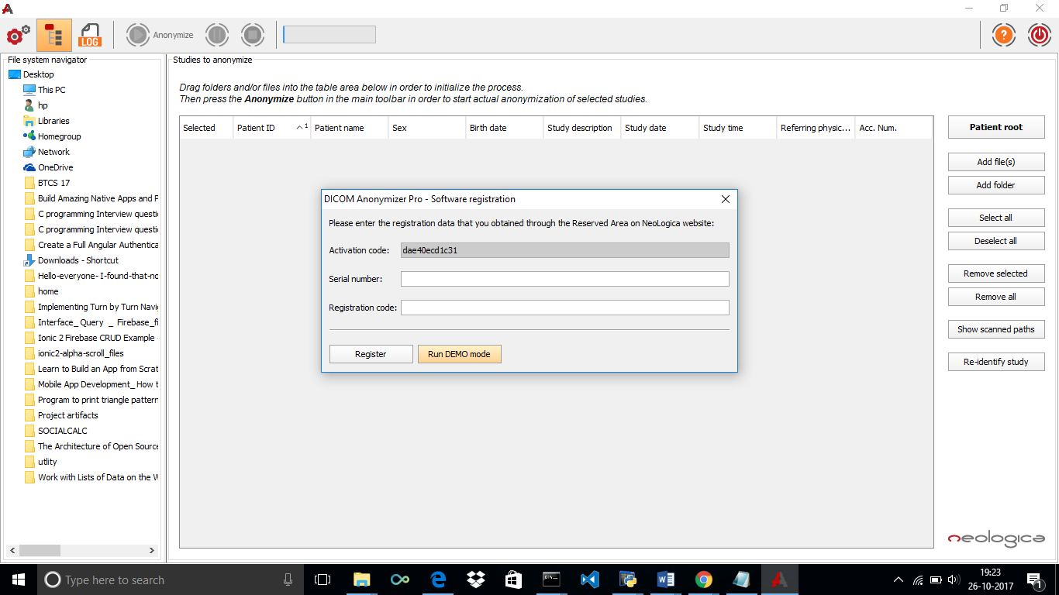

* **Dicom Anonymizer opens up,select Run DEMO mode.**
* **Click Add Folder to select all the files in the folder.**
* **Browse the files from your computer.**

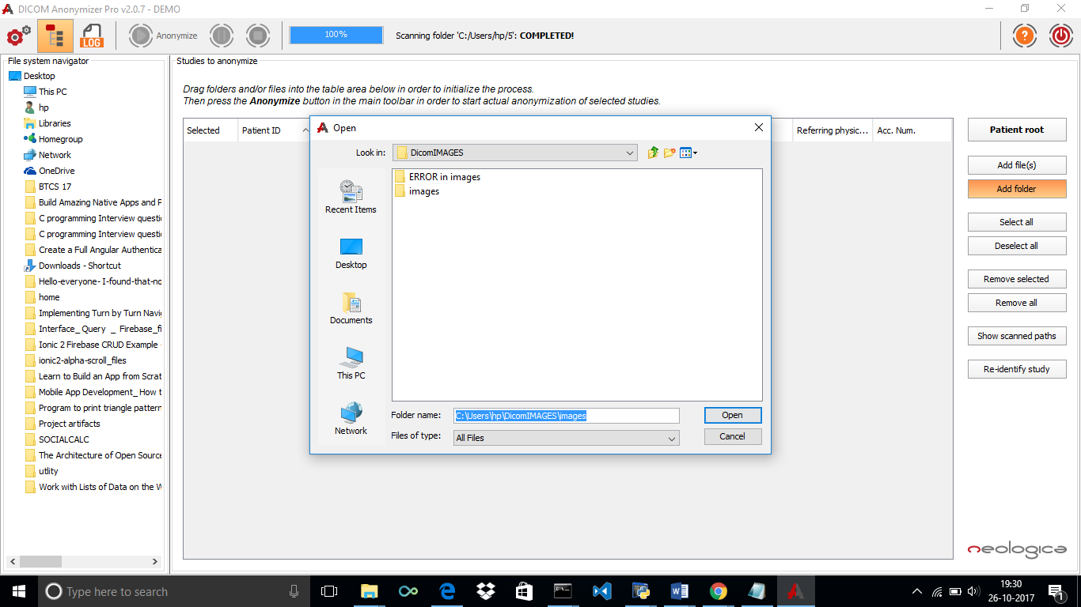

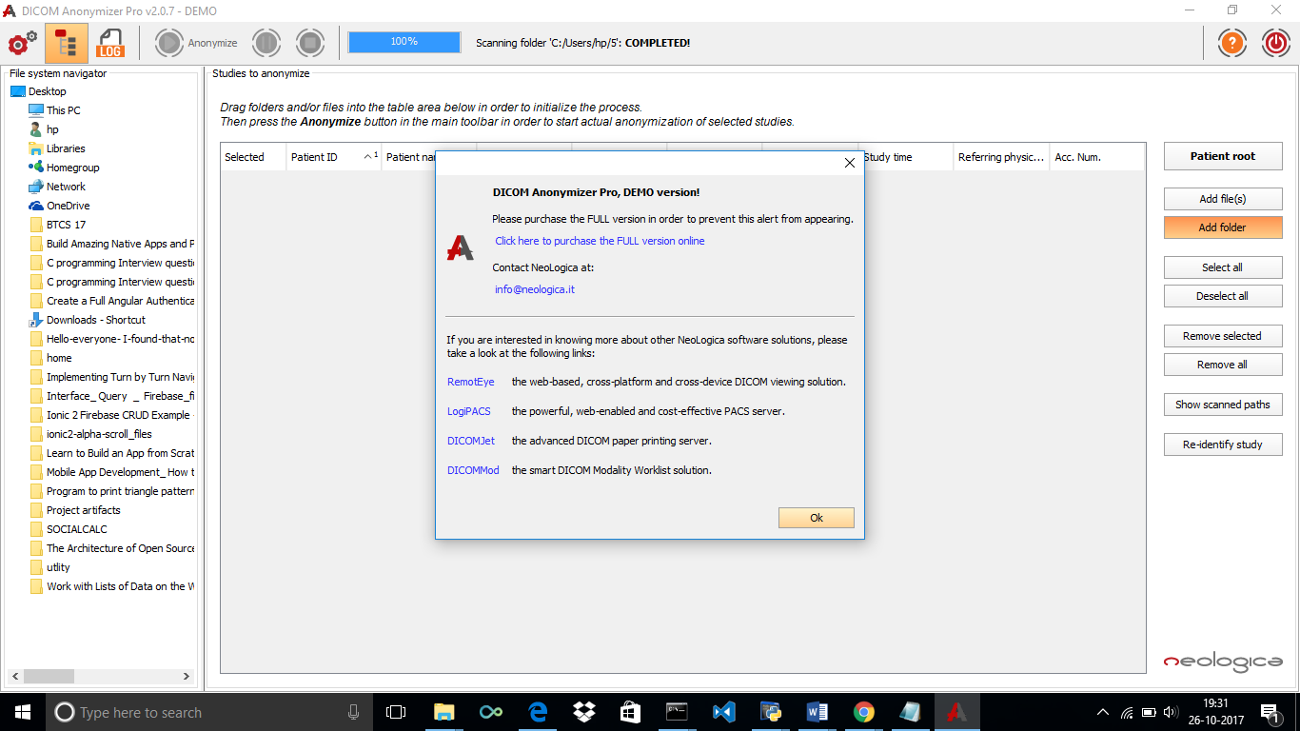

* **Click on OK.**

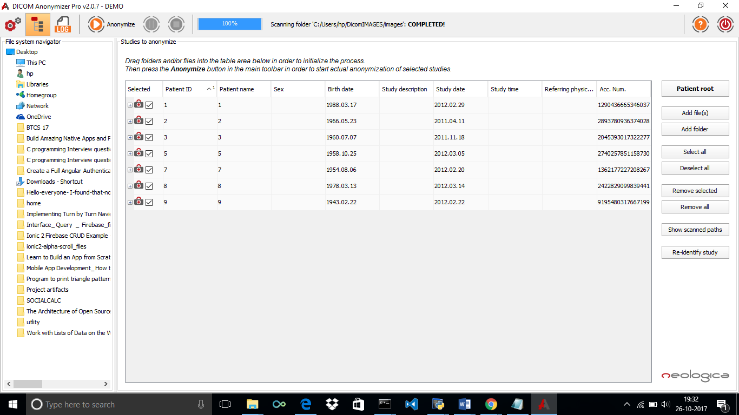

* **The files in the folder appears here.**
* **Select Settings from the left corner.**

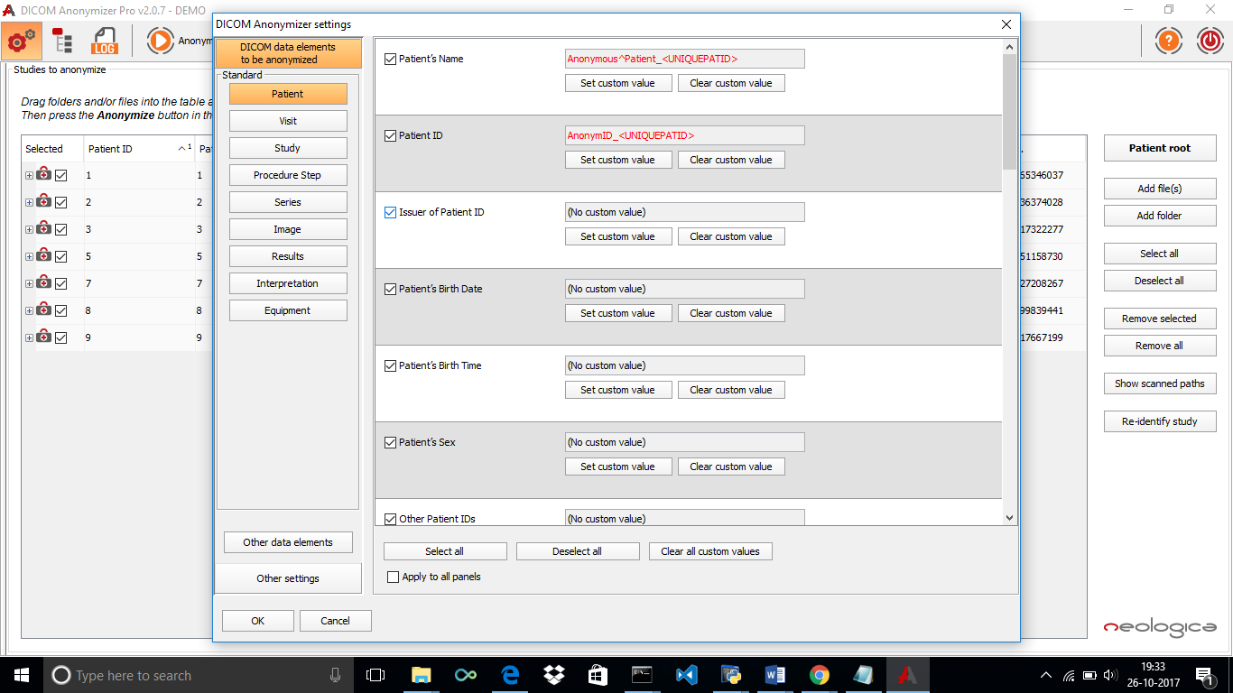

* The Panel on the left shows data elements which are categorized like Patient, Study, Image, Interpretation, results etc.
* The right side shows the data elements corresponding to the selected Standard.
* Click on Select Custom Value and select any dynamic field, in this case we have selected <UNIQUE PATIENT ID>. We can also add our own value to be specified.

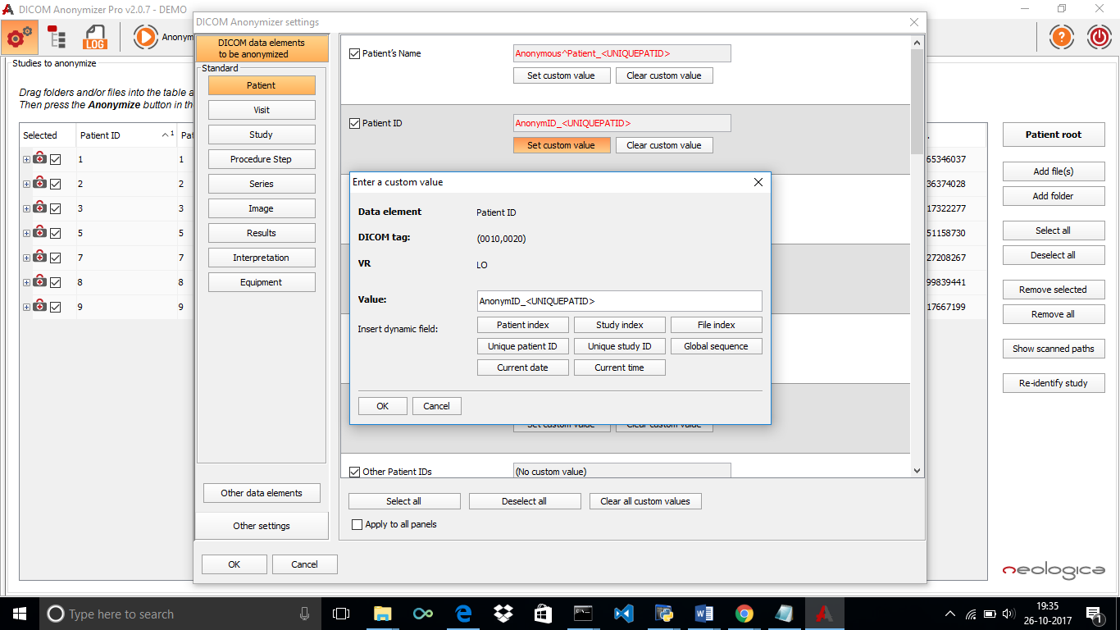

* Click on OK and again OK to apply the changes.
* Click on Anonymize to start Anonymize.
* Open the folder.

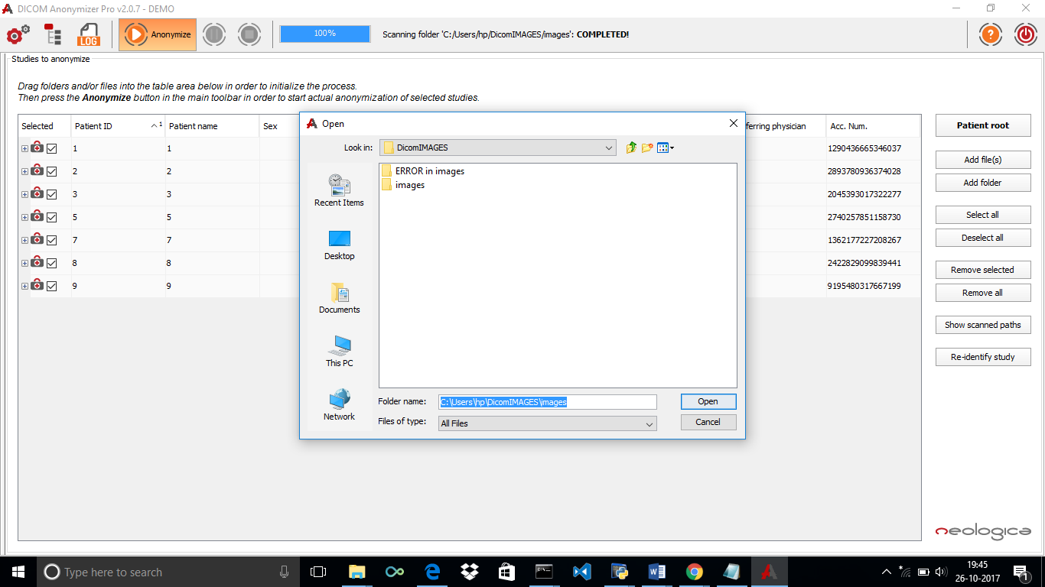

* Select the folder and click on Ok
* Anonymization starts and then a message occurs “Anonymization process Completed”.

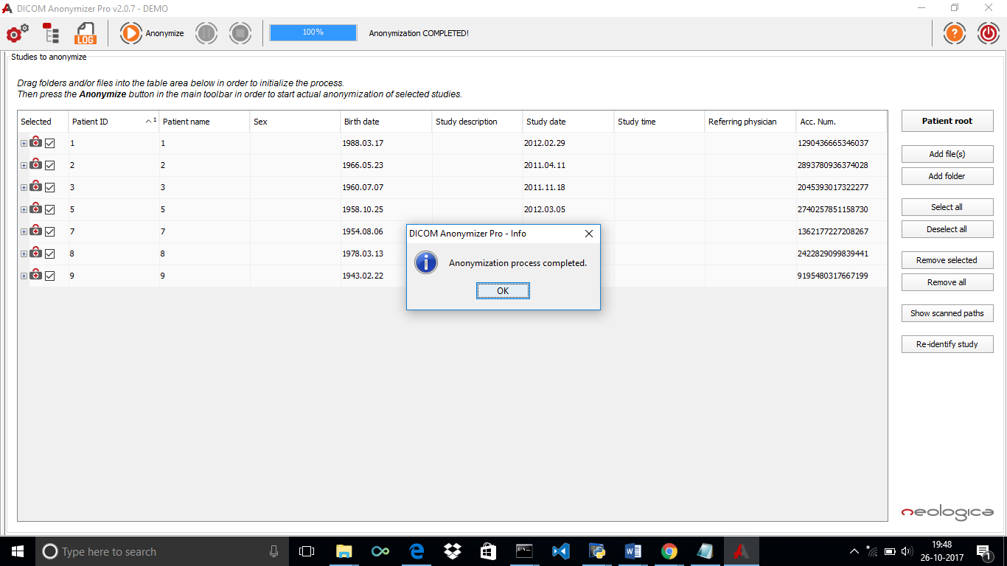

* Select logs to view the results.

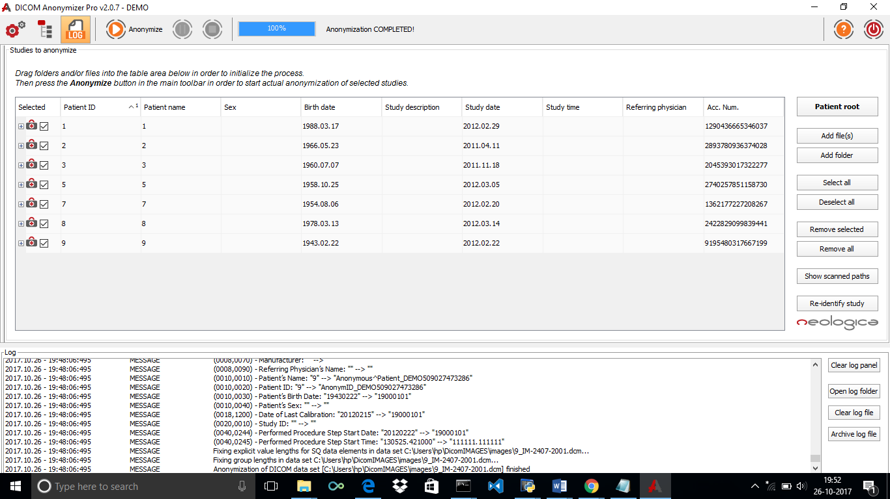

The selected data set gets anonymized and visible in the logs.

* For Example,

Patient Id and Patient name gets Anonymized as below-

2017.10.26 - 19:48:06:495 MESSAGE (0010,0010) - Patient’s Name: "9" --> “Anonymous^Patient_DEMO509027473286"

2017.10.26 - 19:48:06:495 MESSAGE (0010,0020) - Patient ID: "9" --> "AnonymID_DEMO509027473286"